Extra Practice Problems for Quiz # 2
(1.4 – 2.1)

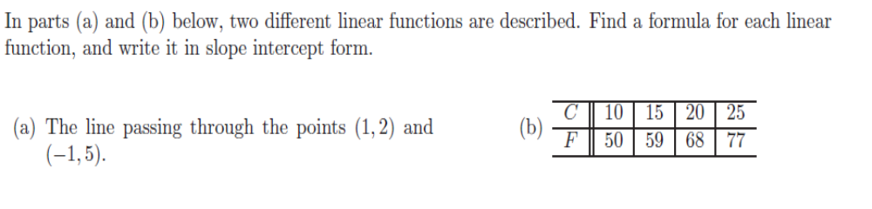

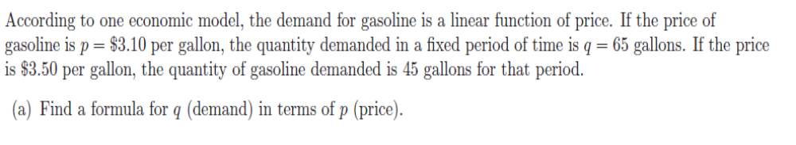
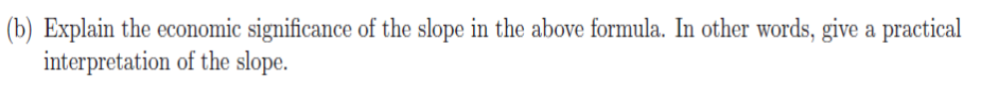

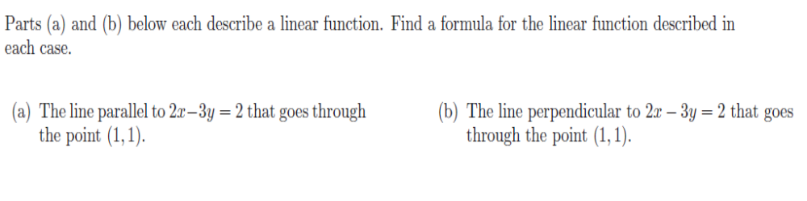
4.
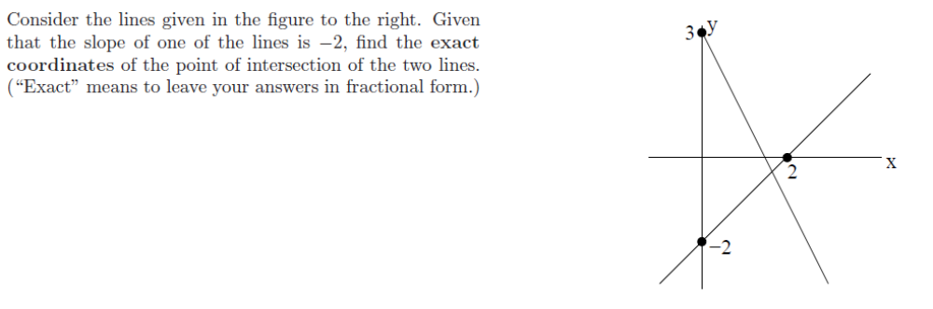

5.
The Little Town Fine Arts Center charges $23 per adult and $12 per
senior citizen for its performances. On a recent weekend evening when
480 people paid admission, the total receipts were $7663. How many
who paid were senior citizens?

6.
7.
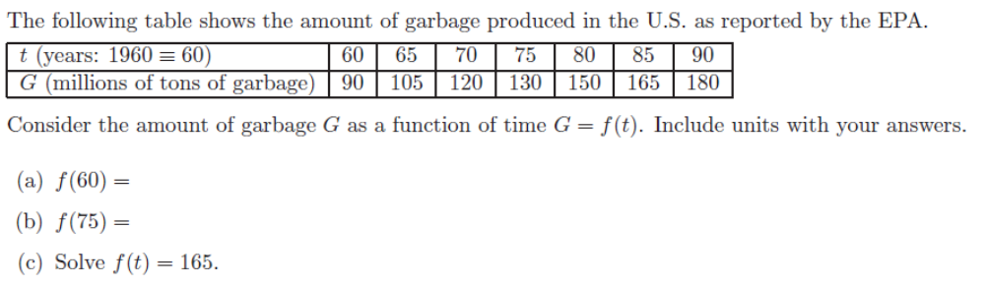
.
8.
Jancie has $180,000 to invest to obtain annual income. She wants some
of it invested in safe Certificates of Deposit yielding 5%. The rest she
wants to invest in AA bonds yielding 12% per year. How much should
she invest in each to realize exactly $17,400 per year?

